

Library Management

Project

 | JAVA Swing |

# 

When you will click on the Admin Login Button.

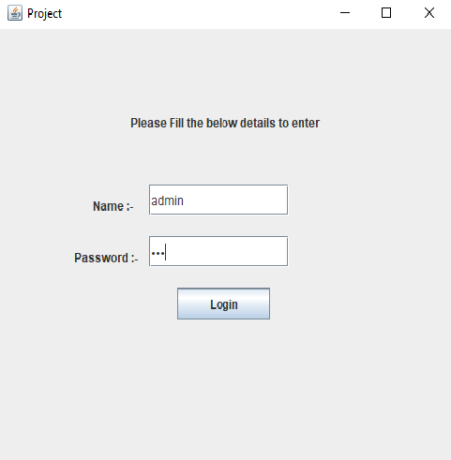

When you will click on the Admin Login Button.

Enter Following Credentials:--

Name:--admin

Password:-123

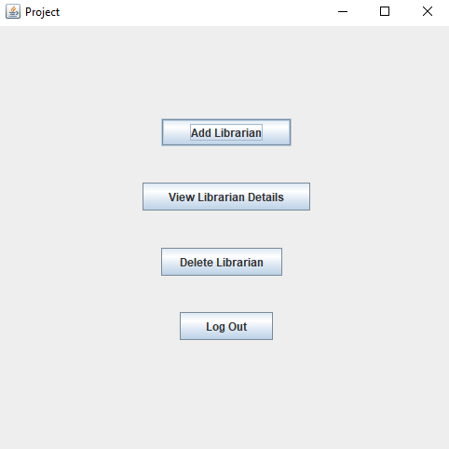

Then

On ADD LIBRARIAN Button & Press Back Button(move to one step back):-

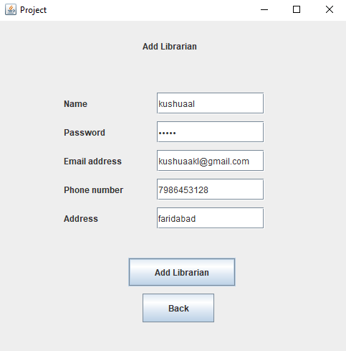

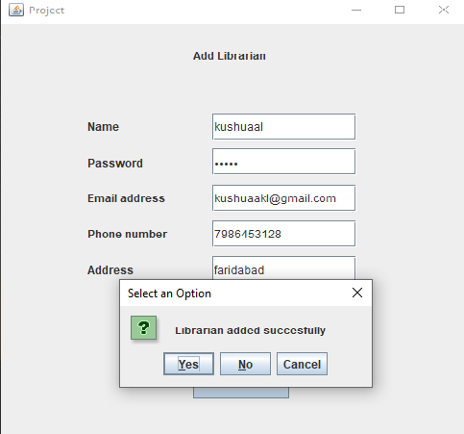 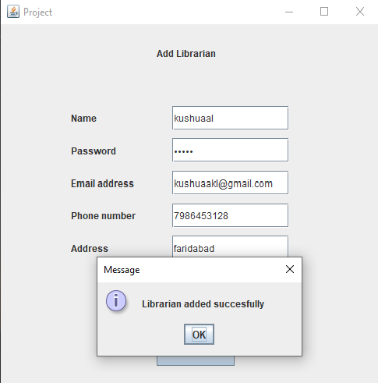

Then

On VIEW LIBRARIAN DETAILS (See details of librarian) Button & Press Back Button(move to one step back):-

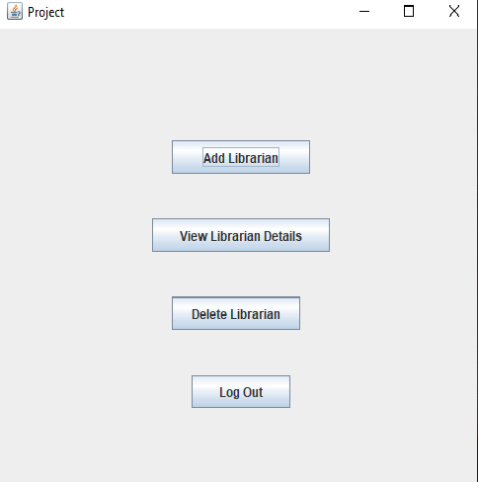

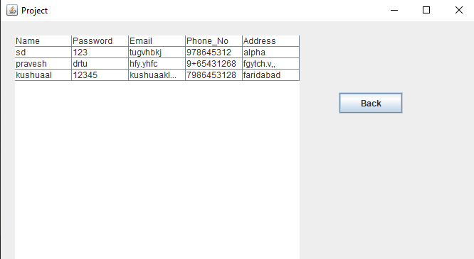

Then

On DELETE LIBRARIAN (delete details of librarian) Button & Press Back Button(move to one step back):-

 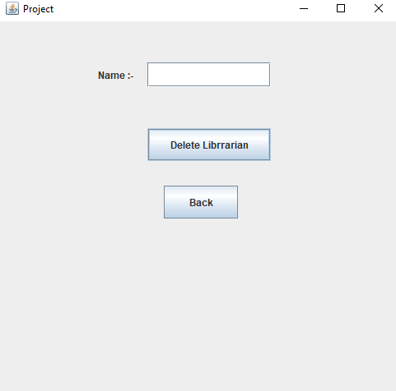



Then

On LOGOUT (close the application) Button :-



Then Reopen the run it :--

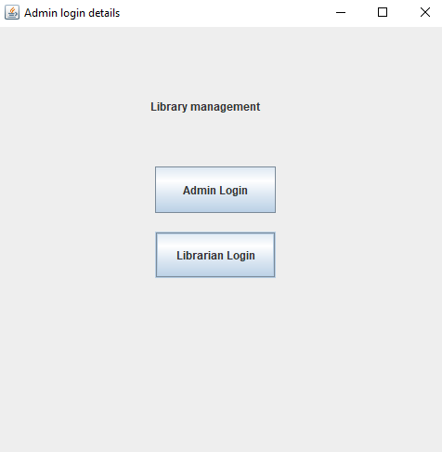

Then

On ADD BOOKS(add books) Button & Press Back Button(move to one step back):-

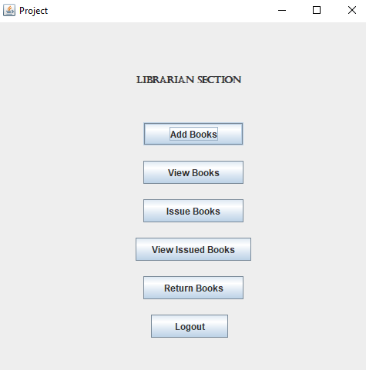

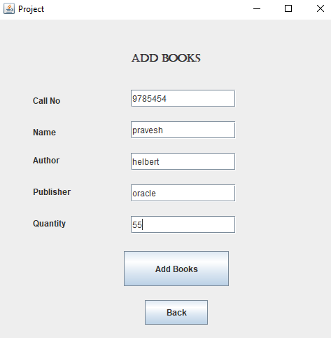

Then click on ADD BOOKS:-

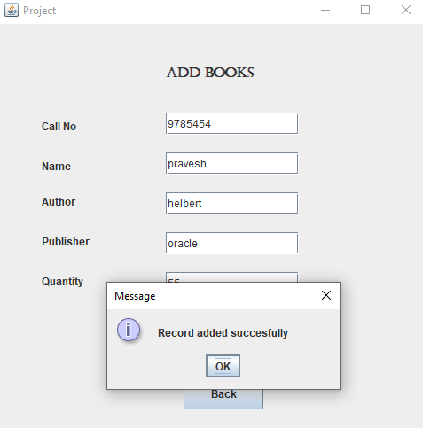



Then

On VIEW BOOKS(view books) Button & Press Back Button(move to one step back):-



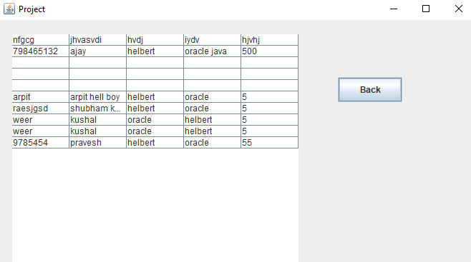

Then

On ISSUE BOOKS(view issued books) Button & Press Back Button(move to one step back):-



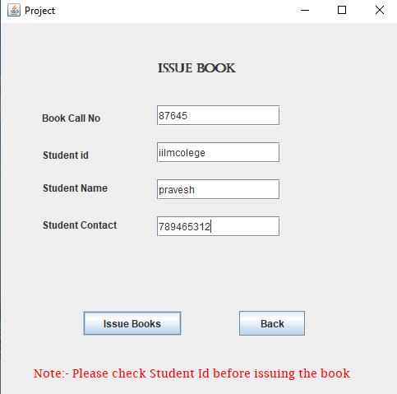 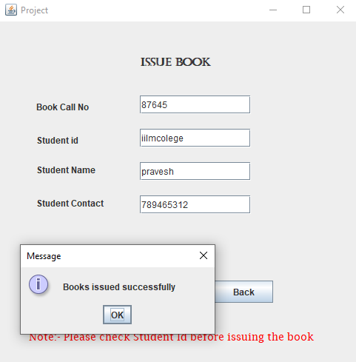

Then,

On RETURN BOOKS(Return books & delete book from the issued books option) Button & Press Back Button(move to one step back):-

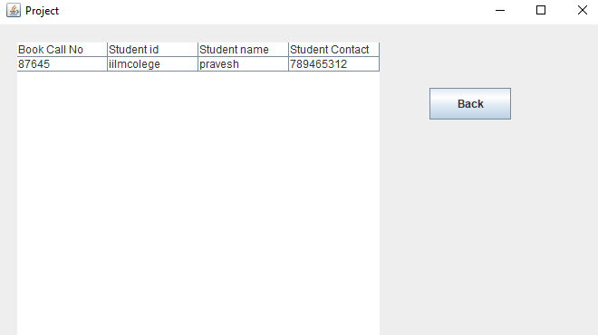

Then

On LOGOUT (close the application) Button :-



Made by:- Anand Shukla